# Task #1

Command line compilation:

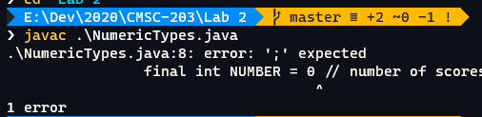

Eclipse compilation

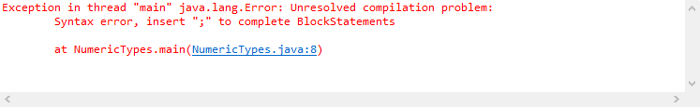

Recompiled

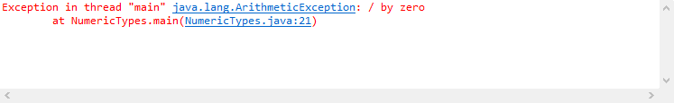

Recompiled (again)

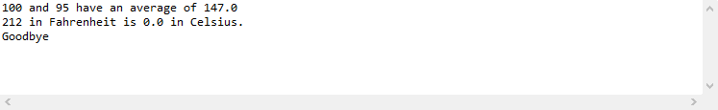

# Task #2

Correcting logic Errors

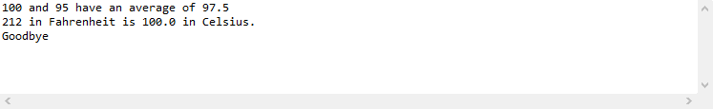

# Task #3

Read inputs and read Fahrenheit

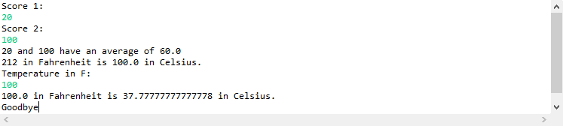

# Task #4

SphereVolume test table results

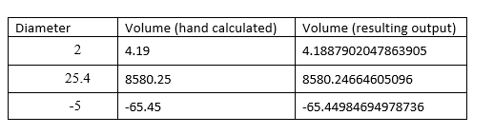

SphereVolume.java screenshots

